IBM Data Science Capstone Project

## Introduction

In order to run a restaurant in Toronto, business owner should find a good local, which can drive a great traffic of clients. With limited resource, it is always to locate a place. Therefore, we suggest deciding based on existing restaurants, which will a great proof to decide whether an area suits to open a restaurant. Based on this theory, we decide to select a place where has high density of restaurants

## Methodology and Analysis

Based on the dataset from Wikipedia, we can find easily find the high density by calculate the restaurant per mile. We can group area by zip and use sum of total restaurants to divide the size of each area. To further refine the place with high density of restaurants, we can utilize the machine learning to find a location where the distance to ten nearby restaurants is the smallest.

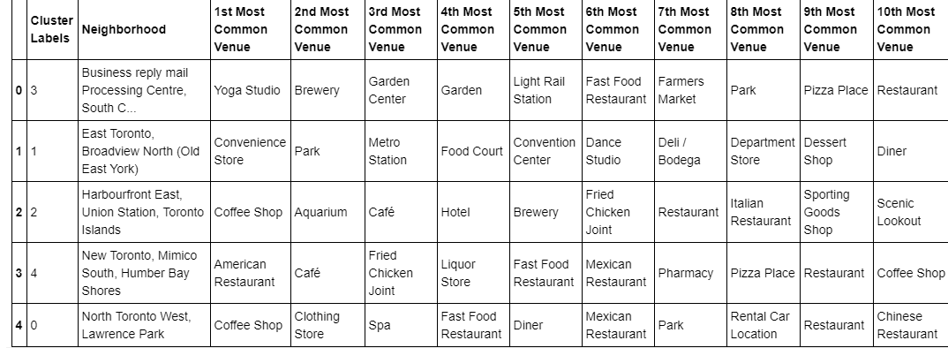

## Conclusion

In a summary, this project was conducted to select a location where the chance of successful is high. We decide the location based the density of existing restaurant at Toronto. The clusters of restaurant show the concentration of restaurant that not only solves the business problem but opens doors to further analysis to decide the branch. Following our theory, we select a location whether the distance to ten closet restaurants are the smallest.